**PSG COLLEGE OF TECHNOLOGY, COIMBATORE – 641 004**

**Department of Applied Mathematics and Computational Sciences**

**MSc SOFTWARE SYSTEMS – Semester IV**

**20XW48 – Web Designing Lab**

**PROBLEM SHEET on Frames and menus**

Create frames and menus using the following models.

1. **Model 1**

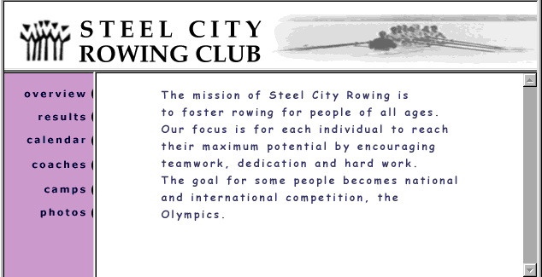

1.html

<!DOCTYPE html>

<html>

<body>

<img src="https://imgcc-a.akamaihd.net/LocFiles/132334/Images/2543456_N_00235_002_13_adLogo.png?width=300&height=162" style="width:1550px; height:200px;">

</body>

</html>

2.html

<!DOCTYPE html>

<html>

<style>

a

{

color: rgb(45,1,85);

font-family: Arial;

font-size:25px;

}

</style>

<body style="background-color: rgb(228, 160, 254);">

<p style="text-align: right;"><a href="3.html" target="right">Overview</a><br><br>

<a href="https://en.wikipedia.org/wiki/Rowing_club" target="right">results</a><br><br>

<a href="https://www.betacalendars.com/yearly-calendar" target="right">calendar</a><br><br>

<a href="https://www.rowinginmotion.com/coaches/" target="right">coaches</a><br><br>

<a href="https://en.wikipedia.org/wiki/Camp_(style)" target="right">camps</a><br><br>

<a href="https://unsplash.com/s/photos/camping" target="right">photos</a></p>

</body>

</html>

</body>

</html>

3.html

<!DOCTYPE html>

<html>

<body style="color:rgb(43,1,85);font-family:Arial;">

<p style="text=align:left; font-size: 28px";>

The mission of steel city rowing is to foster for people for all ages.Out focus is for each individual maximum potential by encouraging teamwork, dedication and hard work. The goal for some people becomes national and international competition, the Olympics.</p>

<body>

</html>

Model.html

1. **Model 2**

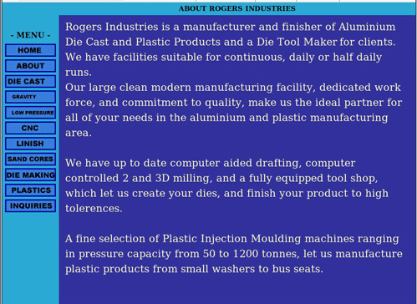

Title.html

<html>

    <body>

        <h1 style="text-align: center;">ABOUT ROGER INDUSTRIES</h1>

    </body>

</html>

Code.html

<html>

    <style>

        button

        {

            width: 100%;

            table-layout: fixed;

            border-collapse: collapse;

            background-color: rgb(79, 79, 250);

            font-weight: bold;

            font-size: 24px;

            padding: 8px;

            border-color: blue;

            border-width: 4px;

        }

    </style>

    <body>

        <h2 style="text-align: center; font-size: 24px;">- MENU -</h2>

        <a href="content.html" target="area"><button>HOME</button></a><br><br>

        <a href="https://www.rogersindustries.com.au/" target="area"><button>ABOUT</button></a><br><br>

        <a href="https://en.wikipedia.org/wiki/Die_casting" target="area"><button>DIE CAST</button></a><br><br>

        <a href="https://en.wikipedia.org/wiki/Gravity" target="area"><button>GRAVITY</button></a><br><br>

        <a href="https://en.wikipedia.org/wiki/Pressure" target="area"><button>LOW PRESSURE</button></a><br><br>

        <a href="https://en.wikipedia.org/wiki/Numerical_control" target="area"><button>CNC</button></a><br><br>

        <a href="https://en.wikipedia.org/wiki/Linishing" target="area"><button>LINISH</button></a><br><br>

        <a href="https://en.wikipedia.org/wiki/Sand_cores" target="area"><button>SAND CORES</button></a><br><br>

        <a href="https://en.wikipedia.org/wiki/Tool_and_die_maker" target="area"><button>DIE MAKING</button></a><br><br>

        <a href="https://en.wikipedia.org/wiki/Plastic" target="area"><button>PLASTICS</button></a><br><br>

        <a href="https://www.rogertechnology.it/en/contact/contact-form" target="area"><button>INQUIRIES</button></a>

</body>

</html>

Content.html

<html>

    <body style="font-size: 30px; font-family:Arial, Helvetica, sans-serif ; color: white;">

        <p>Rogers Industries is a manufacturer and finisher of Aluminium Die Cast and Plastic Products and a Die Tool Maker for clients. We have facilities suitable for continuous, daily or half daily runs.</p>

        <p>Our large clean modern manufacturing facility, dedicated work force, and commitment to quality, make us the ideal partner for all of your needs in the aluminium and plastic manufacturing area.</p>

        <p>We have up to date computer aided drafting, computer controlled 2 and 3D milling, and a fully equipped tool shop, which let us create your dies, and finish your product to high tolerences.</p>

        <p>A fine selection of Plastic Injection Moulding machines ranging in pressure capacity from 50 to 1200 tonnes, let us manufacture plastic products from small washers to bus seats.</p>

    </body>

</html>

Main.html

<!DOCTYPE html>

<html lang="en">

<head>

</head>

<*frameset* rows="10%, 90%">

    <*frame* src="title.html" style="background-color: rgb(16,165,224);"/>

    <*frameset* cols="20%, 80%">

        <*frame* src="code.html" style="background-color: rgb(16, 165, 224);"/>

        <*frame* src="content.html" name="area" style="background-color: rgb(43, 43, 190);"/>

    </*frameset*>

</*frameset*>

<body>

</body>

</html>

**3. Model 3**

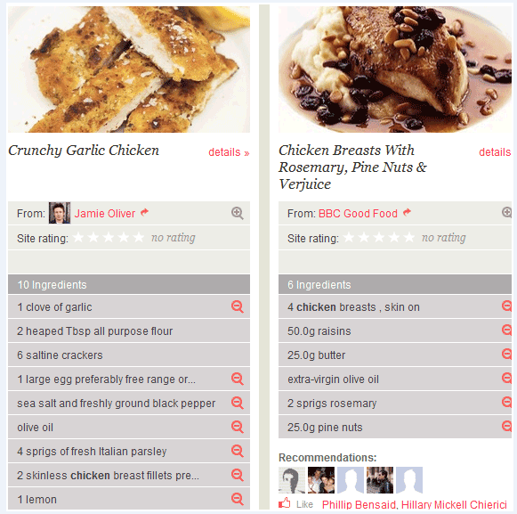

Main.html

<html>

    <body>

        <img src="ragada.jpeg">

        <p style="font-size: 30px; border: none; background-color: white;">Ragada Pattice &nbsp;&nbsp;&nbsp;&nbsp;<a href="https://www.bbcgoodfood.com/recipes/chicken-breasts-rosemary-pine-nuts-verjuice" target="fr2" style="color: red;">details &#x226B;</a></p>

        <table *border*="1" style="background-color: rgb(218, 213, 213); width: 100%; font-size: 25px; border-collapse: collapse; height: 55%; border: solid white;">

            <tr style="background-color: rgb(233, 233, 233);"><td><p>From: <a href="img1.jpg" target="fr2" style="color: red;">BBC Good Food &#x27A6;</a></p></td></tr>

            <tr style="background-color: rgb(233, 233, 233);"><td><p>Site rating: <*font* color="white">&#x2605;&#x2605;&#x2605;&#x2605;&#x2605;</*font*> no rating</p></td></tr>

            <tr style="background-color: rgb(216, 208, 208);"><td><br></td></tr>

            <tr style="background-color: rgb(151, 151, 151); color: white;"><td> ingredients</td></tr>

            <tr><td>gram flour</td></tr>

            <tr><td>coriander</td></tr>

            <tr><td>ghee</td></tr>

            <tr><td>red chilli</td></tr>

            <tr><td>green chillies</td></tr>

            <tr><td>olive oil</td></tr>

            <tr><td>white peas</td></tr>

            <tr><td>25.0g pine nuts</td></tr>

        </table>

        <p style="color: grey; font-size: 25px;">Recommendations:</p>

        <p style="font-size: 20px;">&#128077; Like <*font* color="red">Philip Bensaid, Hillary Mickell Chierici</*font*></p>

    </body>

</html>

Code.html

<html>

    <body>

        <img src="sizzler.jpg">

        <p style="font-size: 30px; border: none; background-color: white;">Veg Sizzler  &nbsp;&nbsp;&nbsp;&nbsp;<a href="https://www.bettycrocker.com/recipes/crunchy-garlic-chicken" target="fr1" style="color: red;">details &#x226B;</a></p>

        <table *border*="1" style="background-color: rgb(218, 213, 213); width: 100%; font-size: 25px; border-collapse: collapse; height: 70%; border: solid white;">

            <tr style="background-color: rgb(233, 233, 233);"><td><p>From: <img src="img2.jpg" width="30px" height="40px">&nbsp;&nbsp;<a href="https://en.wikipedia.org/wiki/Sushant_Singh_Rajput" target="fr1" style="color: red;">James Oliver &#x27A6;</a></p></td></tr>

            <tr style="background-color: rgb(233, 233, 233);"><td><p>Site rating: <*font* color="white">&#x2605;&#x2605;&#x2605;&#x2605;&#x2605;</*font*> no rating</p></td></tr>

            <tr style="background-color: rgb(233, 233, 233);"><td><br></td></tr>

            <tr style="background-color: rgb(151, 151, 151); color: white;"><td> ingredients</td></tr>

            <tr><td>1 clove of garlic</td></tr>

            <tr><td>masala</td></tr>

            <tr><td>boiled vegetables</td></tr>

            <tr><td>1 cup rice </td></tr>

            <tr><td>salt and pepper</td></tr>

            <tr><td>olive oil</td></tr>

            <tr><td>tomato ketchup, chilli sauce </td></tr>

            <tr><td>1 cup noodles</td></tr>

            <tr><td>1 lemon</td></tr>

        </table>

    </body>

</html>

Content.html

<!DOCTYPE html>

<html lang="en">

<head>

</head>

<*frameset* cols="50%, 50%">

    <*frame* src="main.html" name="fr1"/>

    <*frame* src="code.html" name="fr2"/>

</*frameset*>

<body>

</body>

</html>

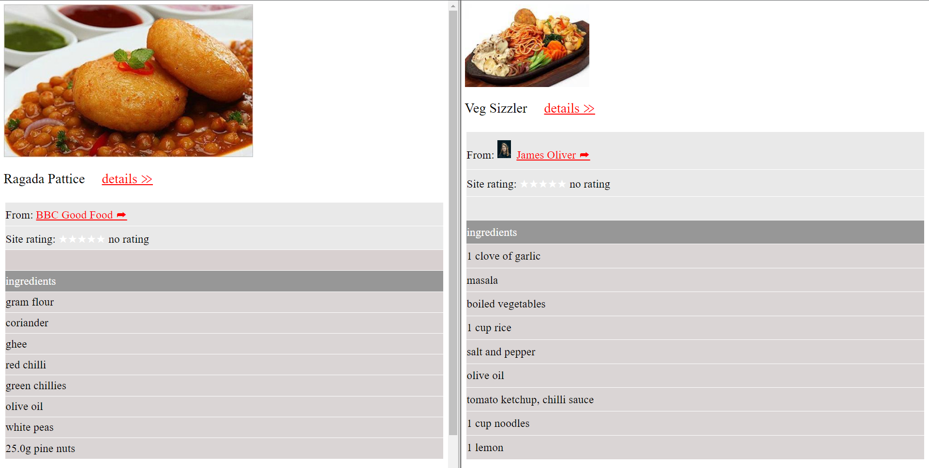

1. **Other frame templates.**

Students can fit in their interested data in the formats and design HTML pages

